Circular 6
Move-in and Move-out Arrangement & Use of Vehicle Permit

Special traffic arrangements will be implemented to minimize pressure to traffic caused on the move-in day (i.e. April 27) and move-out day (i.e. April 30) of the HKTDC Hong Kong International Licensing Show 2025. These measures would be beneficial to both our valued exhibitors as well as the general public. Exhibitors are recommended to pay attention to the details of the new arrangement as below:

(A) Vehicle Permit for Lorries / Light Goods Vehicles
e-Vehicle permit will be issued to each exhibitor for entering the loading/unloading area of the HKCEC on the move-in day (27 April) and throughout the exhibition period (28-30 April). The permit is only valid for use at the specified dates and times indicated on the permit.

Under the new arrangement of Hong Kong Convention and Exhibitions Centre (HKCEC), drivers will need to REGISTER their e-Vehicle permit via the newly launched HKCEC Marshaling App named “Go HKCEC” before entering HKCEC loading area. Drivers have to download the newly launched “Go HKCEC” App to their mobile phones before accessing the loading area of HKCEC. After completion of the registration, drivers can scan QR code on the e-vehicle permits issued by the organiser via the App and obtain a ‘ticket’ and Entry QR code to enter loading area of HKCEC.

Each e-Vehicle permit is for one-time access on the designated date only (i.e., one QR Code for one entry only) and will be invalid after the exact date of entry. Only by showing the QR code on the e-vehicle permit by phone/tablet or in printed version will NOT be allowed for entry, the e-Vehicle permit is ONLY FOR REGISTRATION PURPOSE VIA THE APP. Once the driver has successfully registered on the app, an in-App Notification will be sent to driver when his loading is ready for the truck with an Entry QR Code.
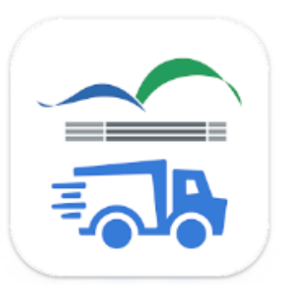
- HKCEC Marshalling App “Go HKCEC”
To safeguard smooth traffic around HKCEC and to minimize the waiting time of truck, HKCEC has launched a new App called “Go HKCEC”. Through this App, lorries / light goods vehicles can obtain queuing ticket, check-in at designated locations and obtain QR code for accessing the HKCEC loading area.

ALL lorries / light goods vehicles that needs to access the HKCEC loading area MUST obtain a ticket via this App before entering HKCEC.

- Download “Go HKCEC” App from the App Store, Google Play, or via APK file
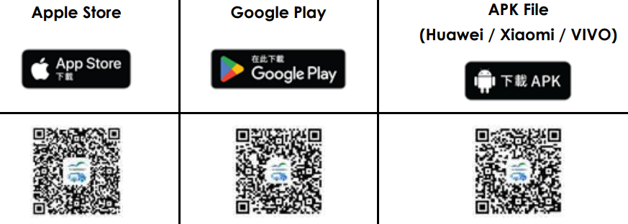

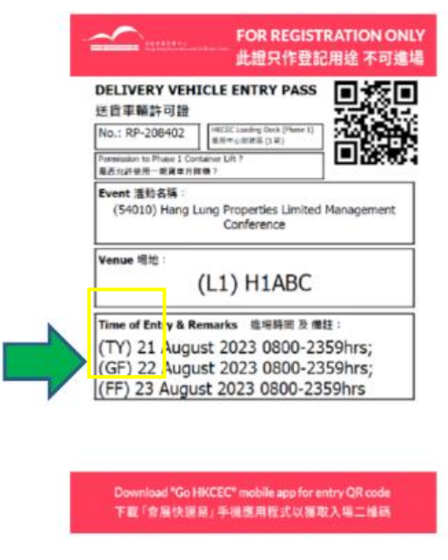
Move-in /out Arrangement
1. Move-in Day 27 April: GF Mode
2. Move-Out Day 30 April: TY Mode

GF Mode
- Upon the Queuing No. being called, “check in” at anywhere outside the Wan Chai Dist.
- An Admission QR Code will be obtained after “check-in”
- Directly go to the HKCEC Marshalling Area for admission

TY Mode
- Upon the Queuing No. being called, go to the Kwai Chung Off-site Area
- An Admission QR Code will be obtained after “check-in” at Kwai Chung Off-site Area
- Directly go to the HKCEC Marshalling Area for admission within the designated time
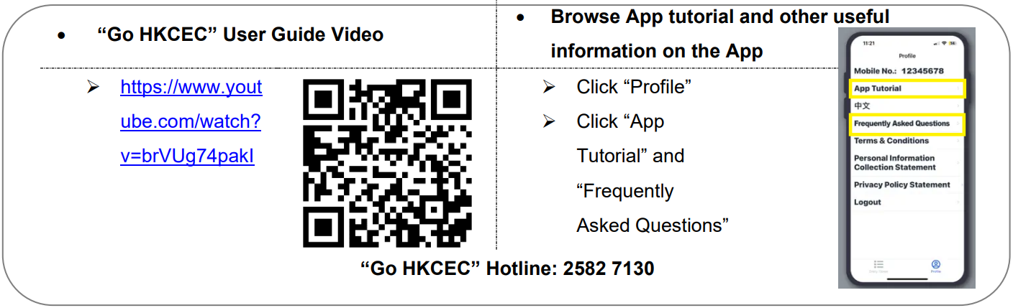
The e-Vehicle permit is for loading and unloading only. No Parking is allowed. Maximum time limit is 45 minutes. Private vehicles are not permitted to enter the loading area. Vehicles will be given a ticket with the clock-in time when entering the HKCEC loading/unloading area. With an aim of alleviating the traffic congestion due to a high usage of loading/unloading facilities, the free-of-charge loading/unloading time during the fair period is limited to 1 st 45-minutes.
The HKCEC will impose charges on vehicles with extended stay on 27 and 30 April. The charges are as follows:
Every 30 mins (or part thereof)
First 45 mins (after clock in) Free
First 2 hours after 45 mins HK$100
After 2 hours & 45 mins HK$150
Each lost ticket HK$500
Payment (if any) will be collected at the exit control booth with official receipt. Please note that vehicle permits are not
suitable for parking purpose, and is not valid for private cars.

(B) Private Car / Taxi
Private cars and taxis will be allowed to enter into the HKCEC at the discretion of the traffic control attendants during the move-in and move-out periods. No waiting or parking at the HKCEC is allowed. Private cars and taxis entering HKCEC will NOT be required to present any Vehicle Permit nor report to the vehicle marshalling area. However, drivers can only unload their goods at the Expo Drive / Harbour Road Entrance of the HKCEC.
The above measure has been implemented in a number of exhibitions and was proven to be effective in alleviating the traffic congestion. Please contact the Organiser for any further enquiries. Thank you for your understanding and cooperation.

Hong Kong Trade Development Council
通告6
進館、撤館之交通安排及車輛許可證之使用須知

本局將於香港國際授權展2025之進館日（即4月27日）及撤館日（即4月30日）實施特別交通安排，以舒緩所引起之交通阻塞，為各參展商及公眾人士帶來更大的方便。請留意以下詳情：

(一) 貨車 / 輕型客貨車 車輛許可證
每家參展商均會獲發一張電子車證，方便於展品進場日(即 2024 年 4 月 27日)及展覽期間(2024 年 4 月 28 日至 30日)進入香港會議展覽中心之裝卸區。此證只適用於許可證上指定之日期及時間。
根據香港會議展覽中心的最新安排，所有貨車/輕型貨車進入卸貨區前，司機須先下載「會展快運易」手機應用程式並完 成簡單登記，司機透過此手機應用程式掃描由主辦單位發出電子版車輛通行證上的二維碼，取得籌號及進塲二維碼後， 方可進入香港會議展覽中心之裝卸區。
參展商獲發的車輛許可證只適用於手機應用程式「會展快運易」上之登記用途，單憑出示電子車證上的二維碼 (QR Code) 並不能直接入場。各張電子版車輛通行證只限於指定日期使用一次*，逾期無效。(*如該張電子車輛通行證已於指定日子 使用一次進入卸貨區，即二維碼已被掃瞄一次，承建商或貨運代理將不能於當天再次使用同一張電子版車輛通行證進入 卸貨區。) 登記成功後，即可根據手機應用程式上的提示及入場二維碼前往香港會議展覽中心。

- 「會展快運易」手機應用程式 展覽期間為了保持香港會議展覽中心週邊交通暢通，香港會議展覽中心推出全新手機應用程式「會展快運易」 (Go HKCEC) 以節省貨車/輕型客貨車的等候時間。透過此應用程式，活動相關車輛可領取排隊籌號、按指示 到指定地點打卡及獲取入場二維碼，再前往香港會議展覽中心。
所有需要進入會展中心一期或二期裝卸區的活動相關車輛，於進入香港會議展覽中心裝卸區前，必須透過「會 展快運易」手機應用程式領取排隊籌號。
- 請於 App Store,、Google Play,商店 或 APK檔案 下載 「會展快運易」手機應用程式。

進場/撤館程序
- 進館日 4 月 27 日: 禁區外打卡模式 (GF Mode)
- 禁區外打卡模式 送貨車輛許可證上的進場時段上看到括號中出現「GF」，代表此時段屬於禁區模式，車輛需在前往會展中心前於禁區外打卡，再前往會展並使用手機應用程式上之進塲二維碼入場
- 撤館日 4 月 30 日: 禁區打卡模式 (TY Mode)
- 送貨車輛許可證上的進場時段上看到括號中出現「TY」， 代表此時段屬於葵涌模式，亦代表前往會展中心前需要先 駛到葵涌。
- 在「我的入場證」頁面中，被叫許可證上出現「請往葵涌」 的狀態更新。此時請按「請往葵涌」。
- 前往會展並使用手機應用程式上之進塲二維碼入場
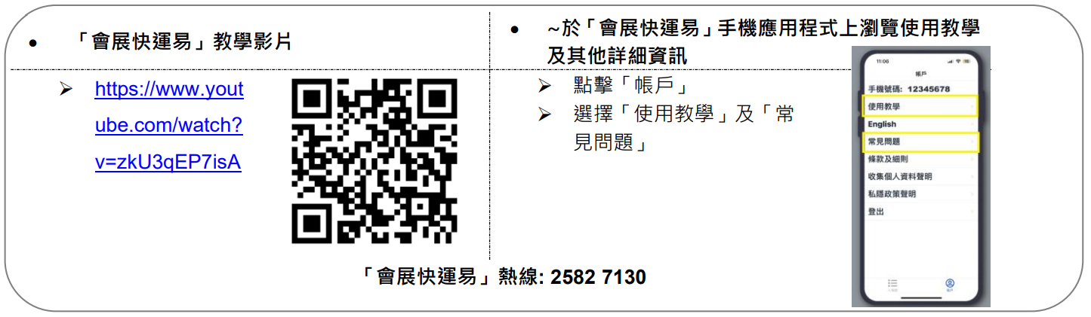
電子車輛許可證只供上落貨之用，時限為 45 分鐘。嚴禁泊車。私家車不可駛入卸貨區。當車輛進入會展貨物起卸區時，司機會收到一張印上進場時間的計時咭。為有效舒緩當日貨物起卸區交通緊張的情況，免費上落貨限時為 45 分鐘。香港 會議展覽中心將於4月27及30日實施進場車輛使用時間收費計劃。有關收費如下︰
每半小時收費(或不足半小時)
車輛進場後首四十五分鐘 免費
其後兩小時內 港幣 100 元
超過兩小時及四十五分鐘 港幣 150 元
遺失進場計時卡(每張/每日) 港幣 500 元
繳交費用(如適用)將於出口管制處辦理，並同時發還收據。許可證並非泊車證，亦不適用於私家車。博覽道展館之裝卸區 只適用於 2.2 米或以下車輛進入。

(二) 私家車 / 的士進場程序
於進館及撤館其間將酌情准許的士及私家車駛入會展中心範圍，但不得停留或候客。進入會展中心之私家車及的士不需 要持有車輛許可證或到車輛等候處報到，唯所有私家車及的士只能於會展中心博覽道／港灣道正門進行落貨。司機於落 貨後必須盡快離開會展中心，不得停留或候客。
以上的安排已在早前的數個展覽會實施，並能有效地紓緩當日的交通情況。如有查詢，請與主辦機構聯絡。多謝各參展 商之諒解及合作。
香港貿易發展局
Kwai Chung – Offsite Marshalling Area 葵涌車輛報到處
CheckPoint Location: Container Port Road South Driving Test Centre
葵涌模式報到地點:貨櫃碼頭南路駕駛考試中心

