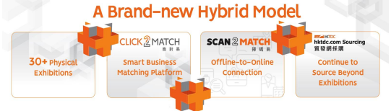
Special Circular : Maximise Your Exhibition Effectiveness with
hktdc.com Sourcing, Click2Match & Scan2Match Platform
Dear Exhibitor,

- hktdc.com Sourcing
As your subscription to hktdc.com Sourcing has begun on 28 March 2025, please be reminded to upload your products to the hktdc.com Sourcing portal so that you can grasp more opportunities to draw the buyers’ attention. We are pleased to share to you the following tutorial video(s) on how to upload your product photos / videos. Your product information will be shown on the fair website from 28 March 2025 onwards which will last for 2 months until 29 May 2025.

The tutorial videos are available in 3 languages:
English: https://sourcingsupport.hktdc.com/hc/en-us/articles/15031116670361
Cantonese: https://sourcingsupport.hktdc.com/hc/zh-hk/articles/15031116670361
Mandarin: https://sourcingsupport.hktdc.com/hc/zh-cn/articles/15031116670361

- Click2Match
Please also be informed that starting from 21 April 2025, exhibitors can login the Click2Match platform to view the buyers’ information and schedule appointments with them for meeting onsite or through video-conferencing (online meetings are available during 21 April – 8 May 2025). You can also find the tutorial videos below for the Click2Match platform below.

English: https://eplussupport.hktdc.com/hc/en-us/articles/15620327016089
Cantonese: https://eplussupport.hktdc.com/hc/zh-hk/articles/15620327016089
Mandarin: https://eplussupport.hktdc.com/hc/zh-cn/articles/15620327016089

- Scan2Match <Brand-new function>
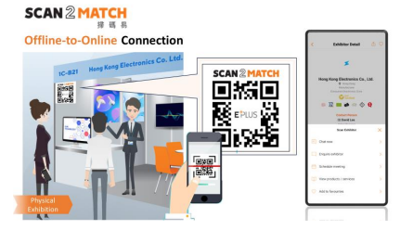
Continue generating sales leads during and even after the physical fair with Scan2Match! Have buyers scan your exhibitor QR code on your booth to obtain a list of potential buyers via Click2Match and continue to connect with them online to explore more business opportunities.

Scan2Match is a new feature of EXHIBITION+ model that enables offline-to-online connection for buyers and exhibitors. Using the HKTDC Marketplace App, buyers can scan the QR codes of exhibitors’ booths and product showcases, allowing them to view product / service detail, schedule meetings, add them to favourites list, view the e-floorplan, and even chat with exhibitors and send enquiries during or after the fair to continue the sourcing journey.

A physical foamboard printed with a unique QR code for will be pre-installed / delivered to exhibitor for each exhibitor on 27 April 2025 (move-in day).

Exhibitors can access the dashboard via the fair website or hktdc.com Sourcing, which provides a summary of the buyers’ profile including the buyer’s name, company, country/region and scan date. Using the Message Centre, exhibitors can initiate a chat with the buyer to start a conversation and build business connections even after physical fair ends.
For more information, please visit：https://eplussupport.hktdc.com/hc/en-us/articles/20414911990041- Scan2Match-Introduction-Who-has-scanned-my-QR-Code-English-5-min-32-sec-

Sample illustrations and recommended placement of the QR Code could be found at the Appendix to this Circular.

特別通告 : 「貿發網採購」、「商對易」及「掃碼易」平台助你提升展覽效益
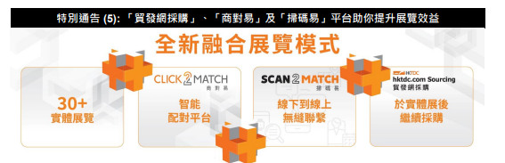
各參展商:

- 「貿發網採購」（hktdc.com Sourcing）

爲期兩個月的「貿發網採購」網上平台推廣服務已經於2025年3月28日開始，請參展商勿忘把產品照片或視頻上載於「貿發網採購」，以吸引更多買家的眼球，爭取更多生意機會。本局特意為各參展商準備了以下的教學視頻，以方便參展商可隨時了解如何上載資料。 參展商的產品資料將會於 2025年3月28日至5月29 日期間於網上展示，為期兩個月。

以下為視頻連結，附有 3 種不同語言供參展商選擇：
英語: https://sourcingsupport.hktdc.com/hc/en-us/articles/15031116670361
廣東話: https://sourcingsupport.hktdc.com/hc/zh-hk/articles/15031116670361
普通話: https://sourcingsupport.hktdc.com/hc/zh-cn/articles/15031116670361

- 「商對易」（Click2Match）

此外，由 2025年4月21日開始，參展商可以登入「商對易」平台，查看已登記的買家資料，並可以透過「商對易」 系統約見買家，於展會的現場進行會議，或透過系統於4月21至5月8日期間進行視像會議。以下為視頻連結， 附有 3 種不同語言供參展商選擇：

英語：https://eplussupport.hktdc.com/hc/en-us/articles/15620327016089
廣東話：https://eplussupport.hktdc.com/hc/zh-hk/articles/15620327016089
普通話：https://eplussupport.hktdc.com/hc/zh-cn/articles/15620327016089

- 「掃碼易」（Scan2Match）<全新功能>
使用「掃碼易」（Scan2Match）讓展商在展覽期間及之後與買家延續聯繫。買家在展覽期間掃描展商攤位內之專屬 二維碼，展商便能透過「商對易」輕鬆收集買家名單並進行線上洽商，尋找更多商機。

「掃碼易」（Scan2Match）是「展覽+」模式的新功能，為買家和參展商提供線下到線上的無縫聯繫。買家可以使用 HKTDC Marketplace (香港貿發局商貿平台) 應用程式，在展位和產品陳列櫃中掃描 Scan2Match 二維碼，與展商建立商貿聯繫。方便買家與展商聯絡、發送訊息、預約會議、瀏覽產品 / 服務詳細信息、將其添加入我的最愛以及查看電子平面圖。

在 4 月 27 日（進館日），大會將於當日派發或預先在展商攤位安裝一個實體二維碼展示板。

展商可以通過展會網站或「貿發網採購」後台，帳戶概覽（dashboard）獲取買家概況摘要，包括買家姓名、公司、 國家/地區和掃描日期。另外，使用訊息中心，展商可以主動聯繫買家，在展會結束後，仍可繼續與已掃描二維碼的買家保持聯繫。

更多資訊，可瀏覽：
https://eplussupport.hktdc.com/hc/zh-hk/articles/20414911990041- %E6%8E%83%E7%A2%BC%E6%98%93%E7%B0%A1%E4%BB%8B- %E8%AA%B0%E6%8E%83%E6%8F%8F%E4%BA%86%E6%88%91%E7%9A%84%E4%BA%8C%E7%B6%AD% E7%A2%BC-%E5%BB%A3%E6%9D%B1%E8%A9%B1-6%E5%88%86-42%E7%A7%92-

二維碼展示板的樣本和建議擺放方法可參考附件。

Scan2Match FAQ
掃碼易常見問題
Q1 | Is there any recommended placement? 有建議的黏貼位置嗎？
Ans1 | Yes. It is recommended to place your company‘s Scan2Match QR Code at 1850mmH, facing the main aisle(s) where feasible. If there are multiple foamboards, it is recommended to place them in consistent areas. The recommended placement is illustrated for respective booth formats in the Appendix for your reference.  有。建議將貴公司專屬的掃碼易二維碼貼於展台面向主通道、離地 1850 毫米高的地方。如有多塊泡沫 板，建議黏貼於整體一致的位置。有關不同展台形式的建議位置，請參閱附件。
Q2 | Is the format of QR Code boards standardized? 二維碼展示版是統一的？
Ans2 | Yes. All QR Code are standardised in 210mmHx210mmW size, made of 5mm foamboard.  是。大會統一現場所有二維碼展示版之尺寸為 210 毫米高 x 210 毫米寬的 5 毫米厚四方形泡沫板，背有 雙面膠紙以便參展商自行黏貼。
Q3 | What should I do if the QR Code broken / missing? 二維碼板損毀／遺失怎麽辦？
Ans3 | Please provide your booth number and contact information to our Sales Representative for reprint and pick up at the FMO.  如需重印，請提供攤位號碼、聯絡方法予相關的營業代表以便我們為你安排重印及領取。領取地點為主 辦機構辦事處。
Q4 | How long does a reprint take? 重印需時多少天？
Ans4 | Please expect the reprint of QR Code would be ready on or before noon the next day.  最快於當天或翌日的中午前。
Q5 | What is Scan2Match? 掃碼易是甚麽？
Ans5 | The Scan2Match QR Code is provided for buyers to scan and access your Company’s (Exhibitor’s) own profile page via the Marketplace APP. For more information, please visit the Scan2Match webpage https://www.hktdc.com/event/exhibitionplus/en/shared-contents/scan2match.  掃碼易二維碼供入場人士透過Marketplace APP掃瞄並開啟貴公司的專有頁面。  了解更多，請瀏覽掃碼易網頁  https://www.hktdc.com/event/exhibitionplus/tc/shared-contents/scan2match (繁) 或  https://www.hktdc.com/event/exhibitionplus/sc/shared-contents/scan2match (简)。
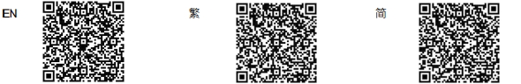

Scan2Match QR Code Illustration / Recommended Placement
「掃碼易」(Scan2Match) 二維碼展示板安裝範例
Scan2Match QR Code Sample 「掃碼易」(Scan2Match) 二維碼展示板樣本
Standard Booth / Premium Booth  Material:  210mmH x 210mmW 5mm thick Foamboard, with double-sided and removable tape on the top and bottom of the back side  Recommended Placement:  1850mmH on the Left & Corner Poles / Structures, facing the main aisle(s) | 標準展台 / 特級展台  材質: 210毫米高 x 210毫米寬, 5毫米厚之發泡展板, 背面貼有雙面可除膠貼  建議展示位置: 張貼於展台面向主通道、離地1850毫米高的可行範圍內
Custom-built Participation (Raw Space)  Material:  210mmH x 210mmW 5mm thick Foamboard, with double-sided and removable tape on the top and bottom of the back side  Recommended Placement:  1850mmH eye-level, facing the main aisle(s), and/or at the main entrance, reception table | 特裝參展(淨地)  材質: 210毫米高 x 210毫米寬, 5毫米厚之發泡展板, 背面貼有雙面可除膠貼  建議展示位置: 張貼於展台面向主通道、接待處，離地1850 毫米高的可行範圍內
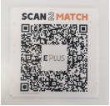  Front:  前: | 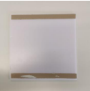  Back:  後:

Scan2Match QR Code Recommended Placement
「掃碼易」(Scan2Match) 二維碼展示板建議展示位置

Please install the QR code at 1850mmH on the Left & Corner Poles / Structures, facing the main aisle(s).
請張貼於展台面向主通道之左面、離地 1850 毫米高之可行範圍內。

Examples of Scan2Match QR Code Foamboard recommended placement
「掃碼易」(Scan2Match) 二維碼展示板建議展示位置例子
標準展台 / 特級展台
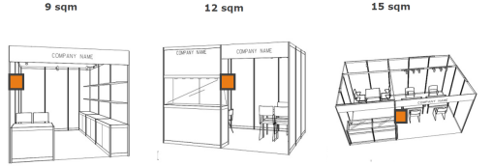

Custom-built Participation (Raw Space) 特裝參展(淨地)
